Name: | Prerna Sunil Jadhav
Sap Id: | 60004220127
Class: | T. Y. B.Tech (Computer Engineering)
Course: | Advanced Database Management System Laboratory
Course Code: | DJ19CEEL5012
Experiment No.: | 02

AIM: Simulate Query optimization
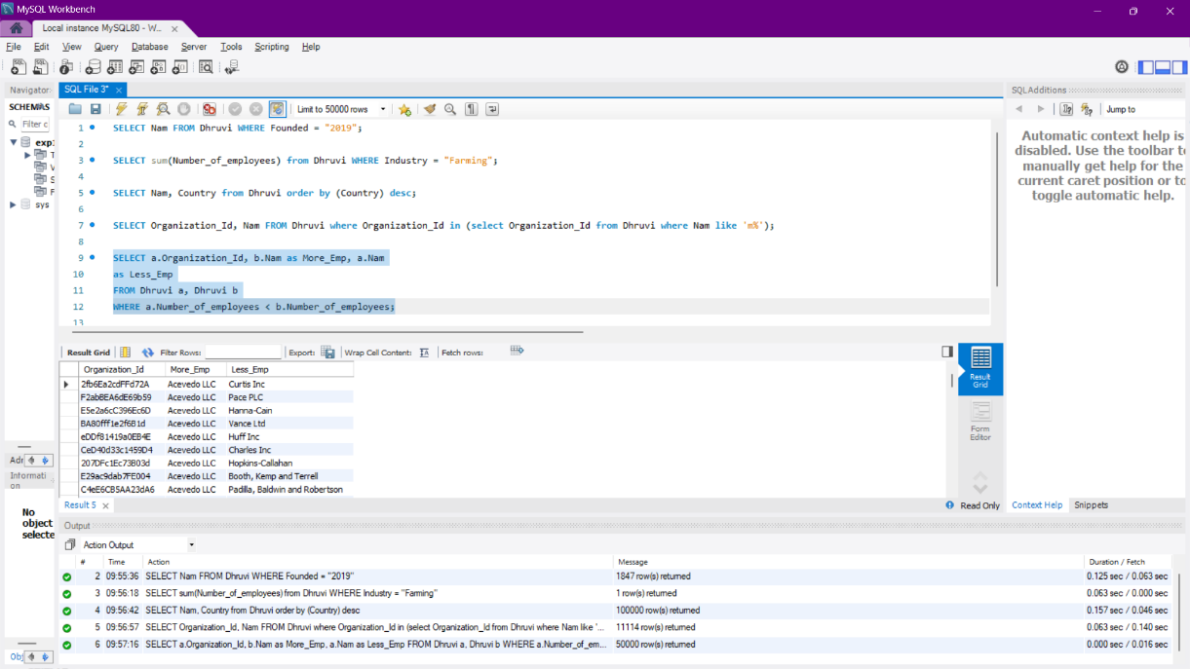

Optimised:
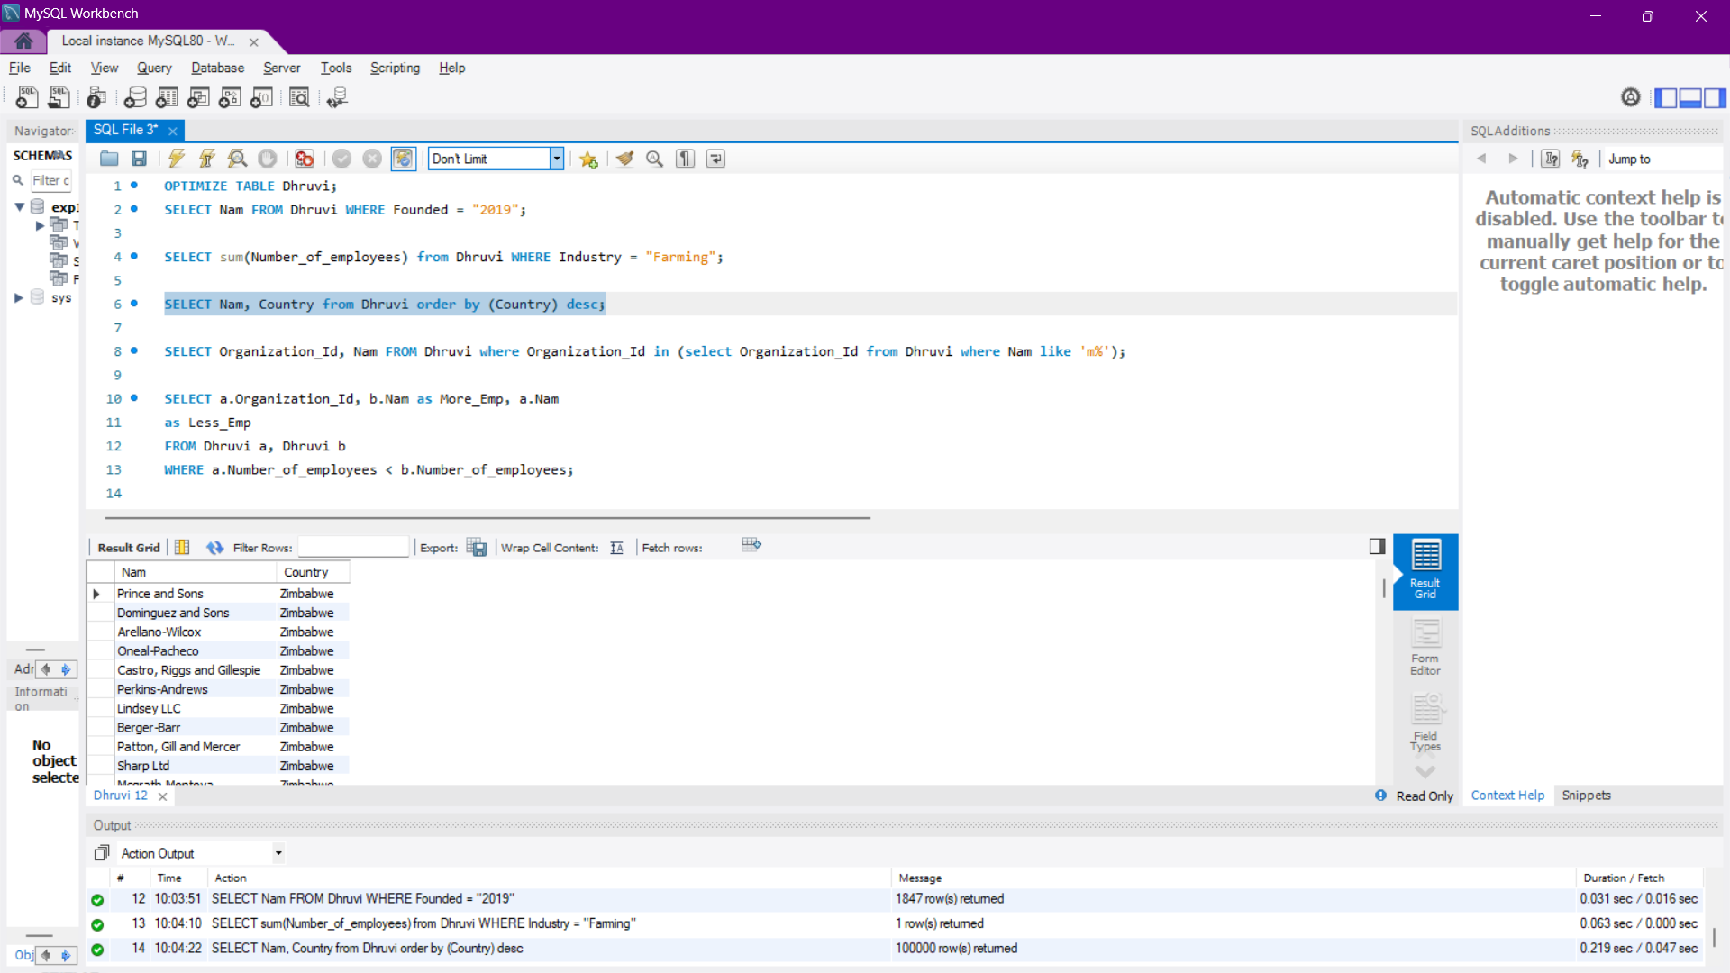
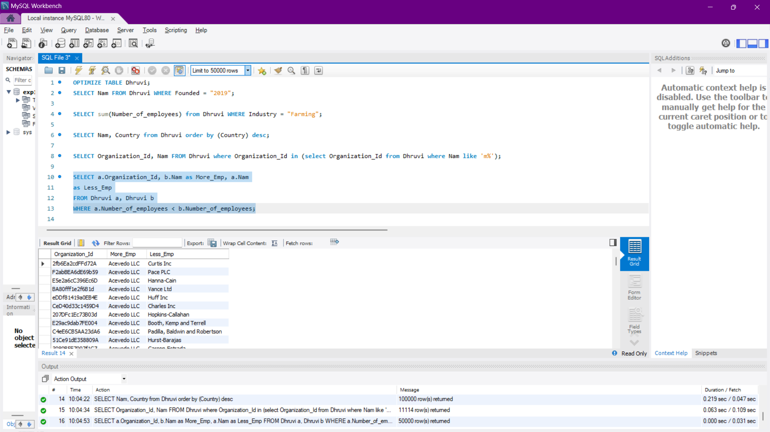
Indexed:
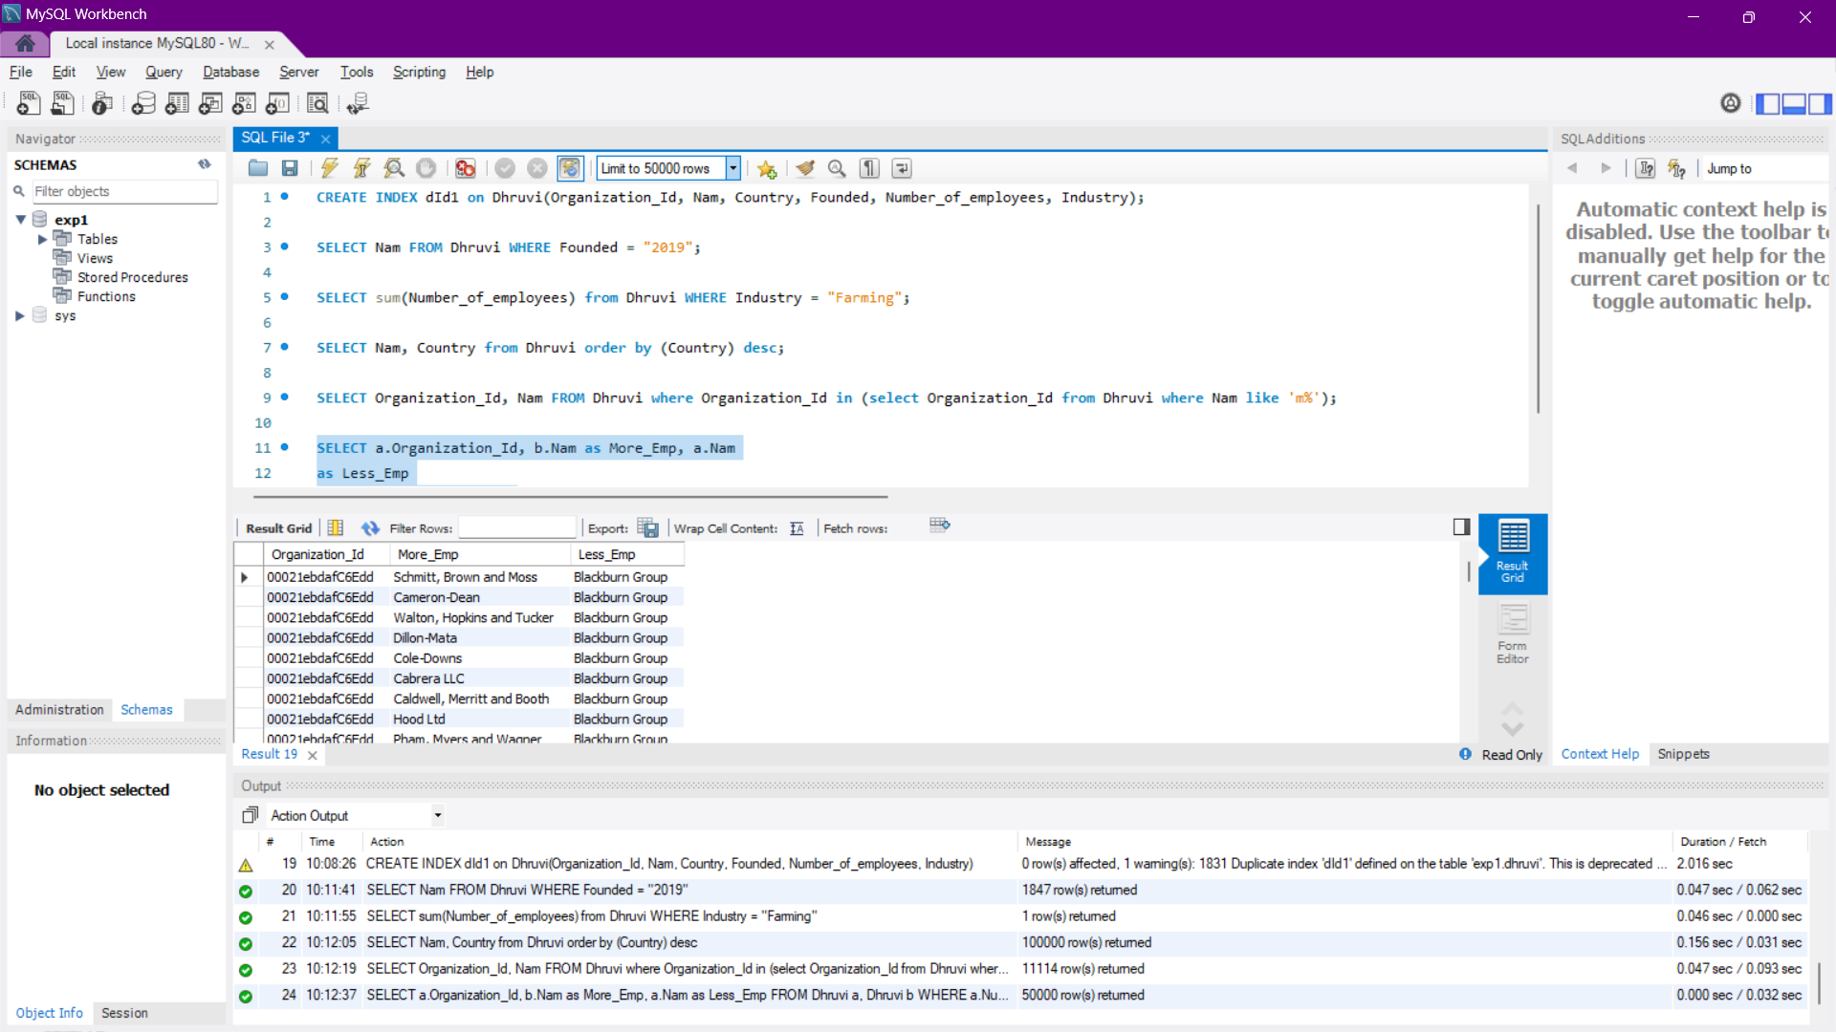

Name: | Prerna Sunil Jadhav
Sap Id: | 60004220127
Class: | T. Y. B.Tech (Computer Engineering)
Course: | Advanced Database Management System Laboratory
Course Code: | DJ19CEEL5012
Experiment No.: | 03

AIM: Implement Query Monitor
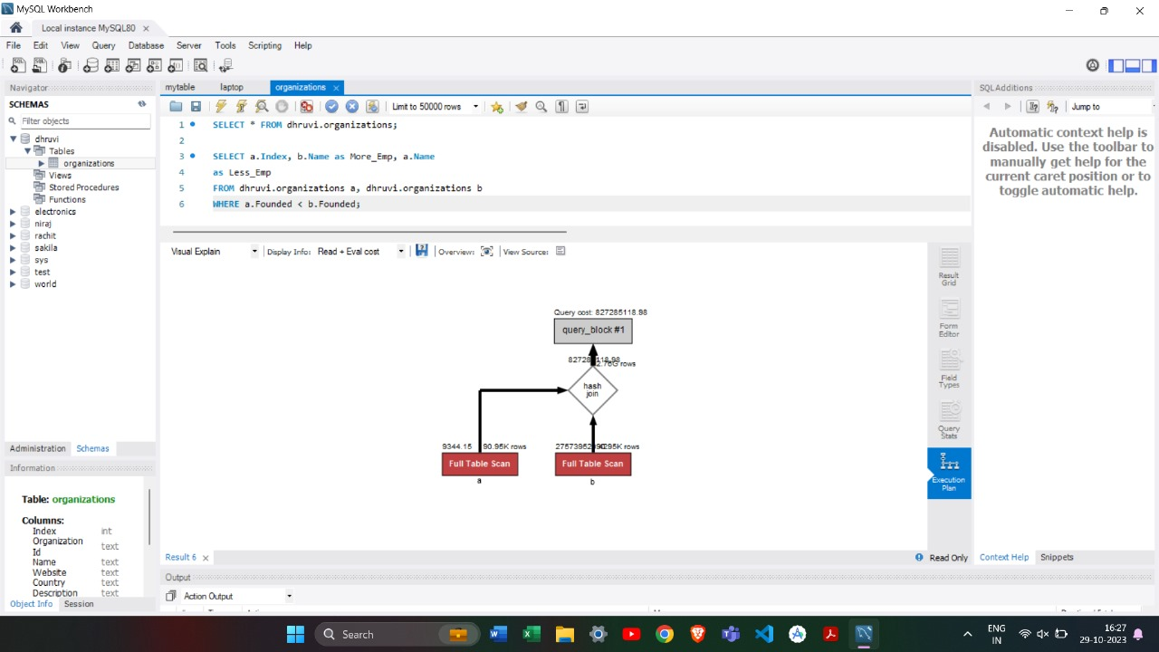

Name: | Prerna Sunil Jadhav
Sap Id: | 60004220127
Class: | T. Y. B.Tech (Computer Engineering)
Course: | Advanced Database Management System Laboratory
Course Code: | DJ19CEEL5012
Experiment No.: | 04

AIM: Optimize using B and B+ trees
CODE:

OUTPUT:

Name: | Prerna Sunil Jadhav
Sap Id: | 60004220127
Class: | T. Y. B.Tech (Computer Engineering)
Course: | Advanced Database Management System Laboratory
Course Code: | DJ19CEEL5012
Experiment No.: | 05

AIM: Perform Fragmentation (Range, List, Hash and Key)
CODE:
Number of records = 20
Partitioning by Range:
CREATE TABLE employees ( id INT NOT NULL,
fname VARCHAR(30), lname VARCHAR(30),
hired DATE NOT NULL DEFAULT '1970-01-01',
store_id INT NOT NULL
) PARTITION BY RANGE(store_id)(
partition p0 values less than (3), partition p1 values less than (6), partition p2 values less than (9), partition p3 values less than (12)
);

Partitioning by List:
CREATE TABLE employees2 ( id INT NOT NULL,
fname VARCHAR(30), lname VARCHAR(30),
hired DATE NOT NULL DEFAULT '1970-01-01',
store_id INT NOT NULL ,
PARTITION BY LIST(store_id)(
partition p0 values in (1,4,6), partition p1 values in (2,3,8), partition p2 values in (5,7,9), partition p3 values in (10,11,12)
);

Partitioning by Key:
CREATE TABLE employees3 (
id INT NOT NULL PRIMARY KEY, fname VARCHAR(30), lname VARCHAR(30),
hired DATE NOT NULL DEFAULT '1970-01-01',
store_id INT NOT NULL
) PARTITION BY KEY() PARTITIONS 4;

Partitioning by Hash:
CREATE TABLE employees4 (
id INT NOT NULL PRIMARY KEY, fname VARCHAR(30), lname VARCHAR(30),
hired DATE NOT NULL DEFAULT '1970-01-01',
store_id INT NOT NULL
) PARTITION BY HASH(id) PARTITIONS 4;

Name: | Prerna Sunil Jadhav
Sap Id: | 60004220127
Class: | T. Y. B.Tech (Computer Engineering)
Course: | Advanced Database Management System Laboratory
Course Code: | DJ19CEEL5012
Experiment No.: | 06

AIM: Implementations of two-phase protocol.
import time
import random
class Coordinator:
def __init__(self, participants):
self.participants = participants

def send_prepare(self):
votes = []
for participant in self.participants:
try:
vote = participant.prepare()
votes.append(vote)
except Exception as e:
print (f"Error during prepare phase: {str(e)}")
self.send_abort()
if all (votes):
self.send_commit()
else:
self.send_abort()

def send_commit(self):
for participant in self.participants:
try:
participant.commit()
except Exception as e:
print (f"Error during commit phase: {str(e)}")
self.send_abort()
def send_abort(self):
for participant in self.participants:
try:
participant.abort()
except Exception as e:
print (f"Error during abort phase: {str(e)}")
self.send_abort()

class Participant:
def __init__(self, name):
self.name = name
def prepare(self):
print (f"{self.name}: Prepare phase")
time.sleep(random.uniform(0.5, 1.5))
return True
def commit(self):
print (f"{self.name}: Commit phase")
time.sleep (random.uniform(0.5, 1.5))
pass
def abort(self):
print(f"{self.name}: Abort phase")
time.sleep(random.uniform(0.5, 1.5))
pass

participant1 = Participant("Participant1")
participant2 = Participant("Participant2")
coordinator = Coordinator([participant1, participant2])
try:
coordinator.send_prepare()
print("Transaction committed successfully!")
except Exception as e:
print (f"Transaction aborted: {str(e)}")

OUTPUT:
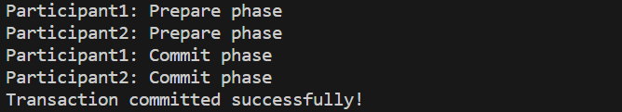

Name: | Prerna Sunil Jadhav
Sap Id: | 60004220127
Class: | T. Y. B.Tech (Computer Engineering)
Course: | Advanced Database Management System Laboratory
Course Code: | DJ19CEEL5012
Experiment No.: | 07

AIM: Query execution on XML database.
CODE:
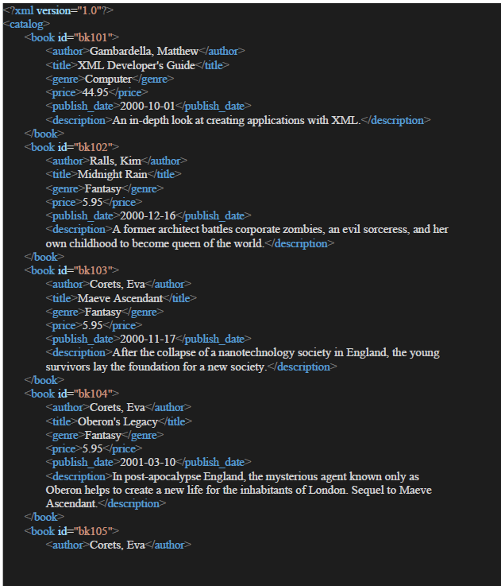
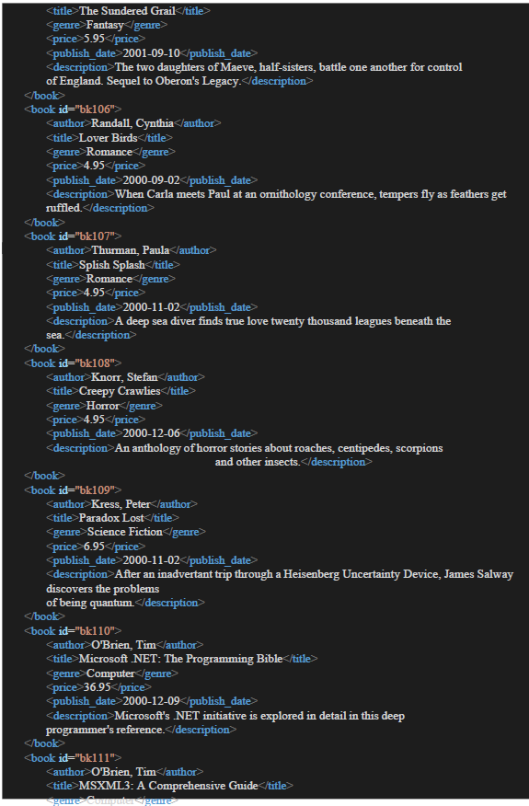
OUTPUT:

Name: | Prerna Sunil Jadhav
Sap Id: | 60004220127
Class: | T. Y. B.Tech (Computer Engineering)
Course: | Advanced Database Management System Laboratory
Course Code: | DJ19CEEL5012
Experiment No.: | 08

AIM: Data handing using JSON
CODE:

OUTPUT:
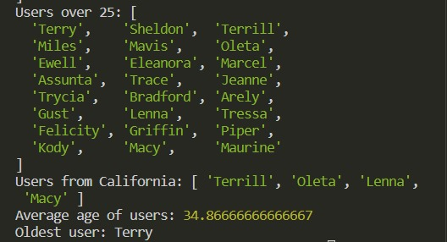

Name: | Prerna Sunil Jadhav
Sap Id: | 60004220127
Class: | T. Y. B.Tech (Computer Engineering)
Course: | Advanced Database Management System Laboratory
Course Code: | DJ19CEEL5012
Experiment No.: | 09

AIM: Processing of Spatial and temporal data.
DATA:
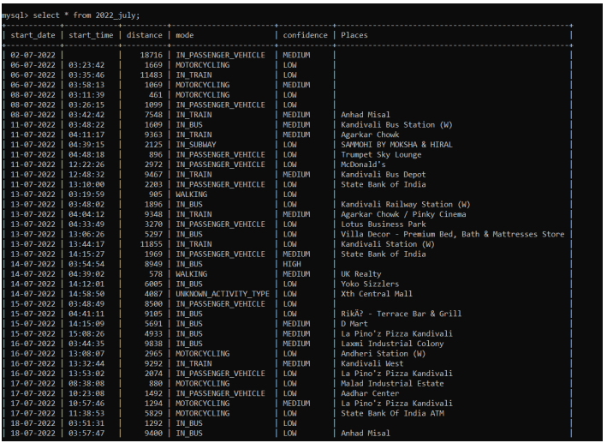
Queries -
- select * from 2022_july where start_time < “04:00:00”;
- select * from 2022_july where distance > 10000;
- select * from 2022_july where Places = “Doolally Taproom - Andheri”;

OUTPUT:
TEMPORAL:
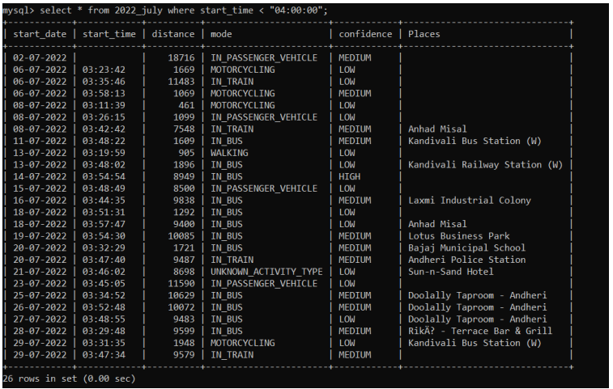
SPATIAL:
